1. Installation and Partitioning

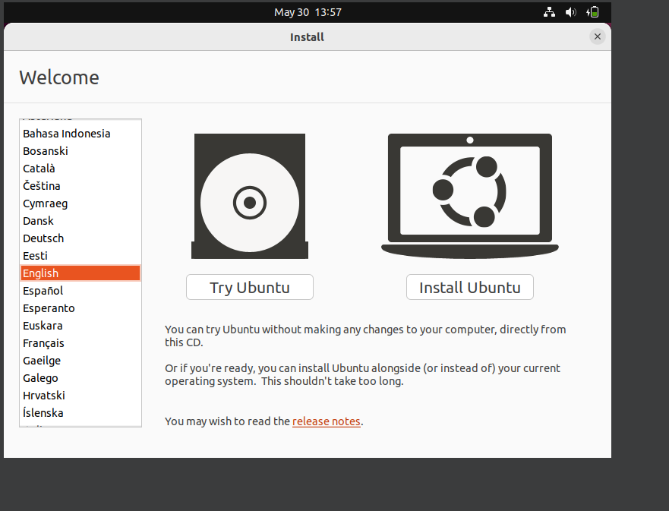 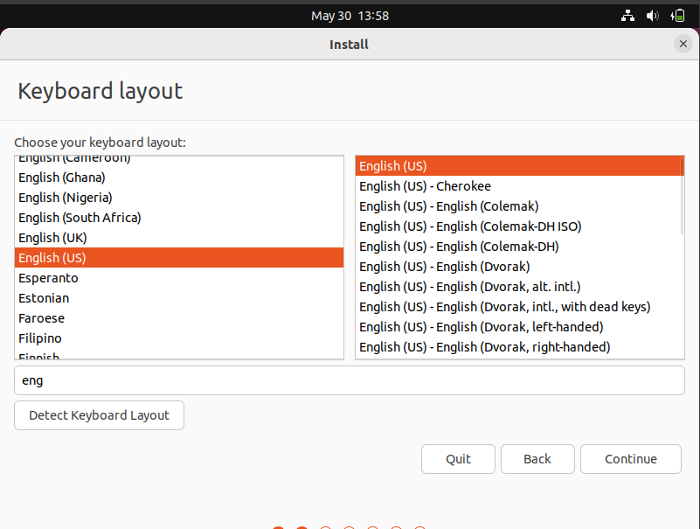

-At first install ubuntu to VM

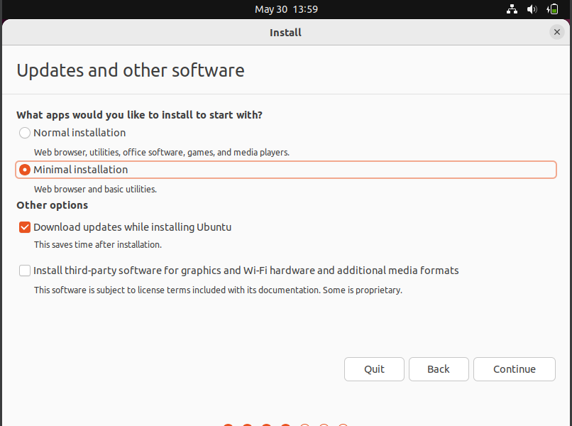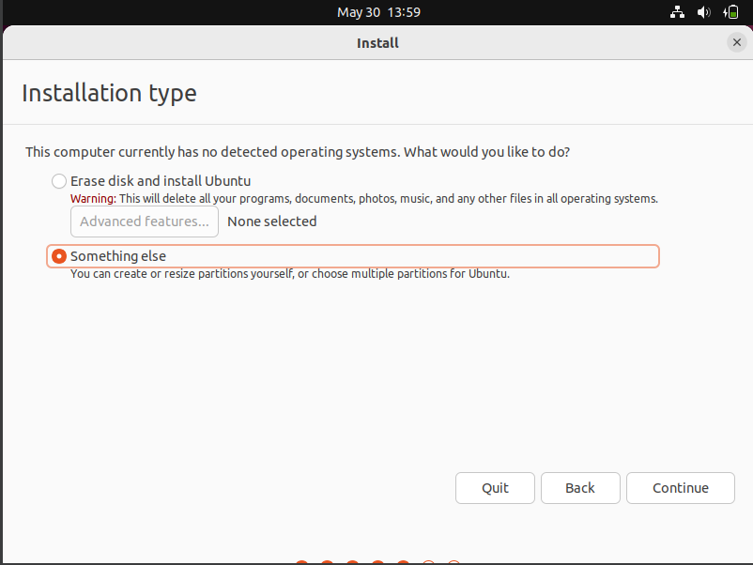

-After that choose installation type “Something else” for manual partitioning to separate partitions

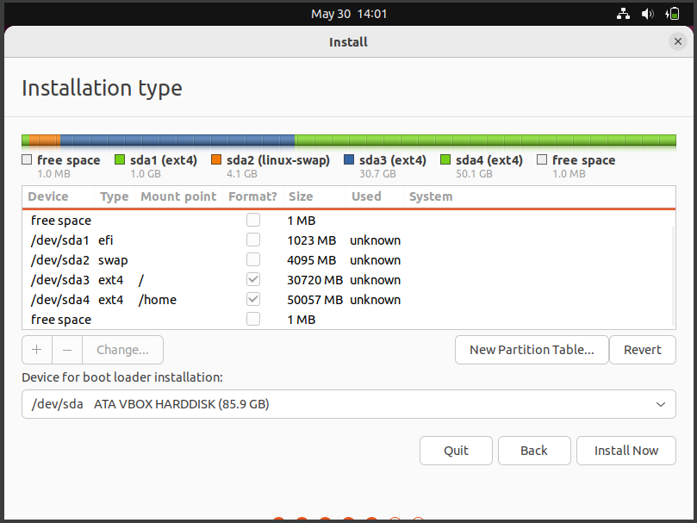

-Separate disk to root “/” home “/home” and swap parts

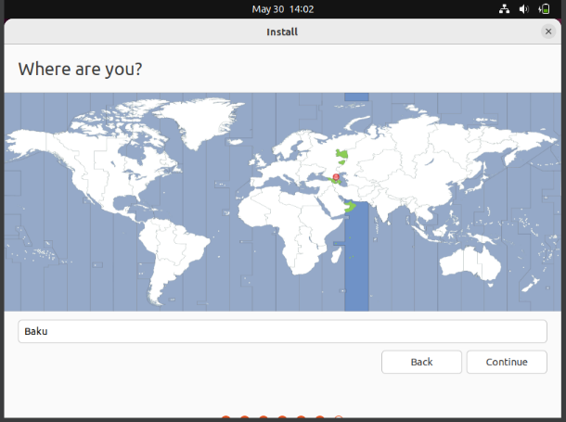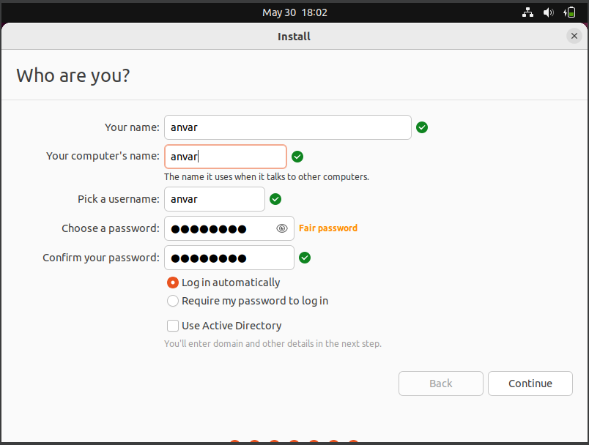

-Choose region and set hostname as my name.

1. Bootloader Configuration and System Recovery

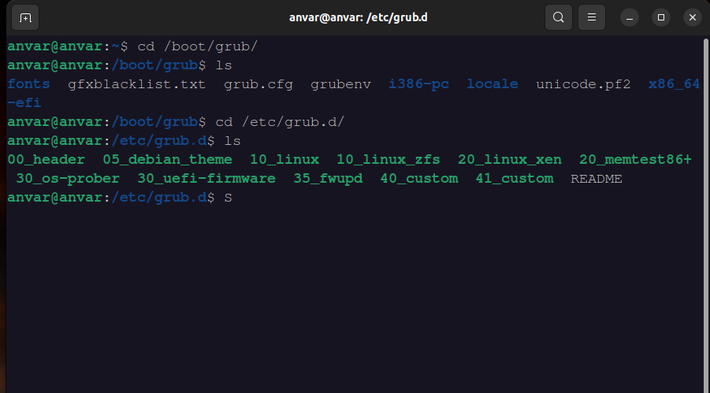

-Boot configuration file is located at “/boot/grub/grub.cfg” but directly configuring it dangerous.

-Add configuration script “Sytem shutdown” into “/etc/grub.d/40_custom” for adding shutdown option into boot menu

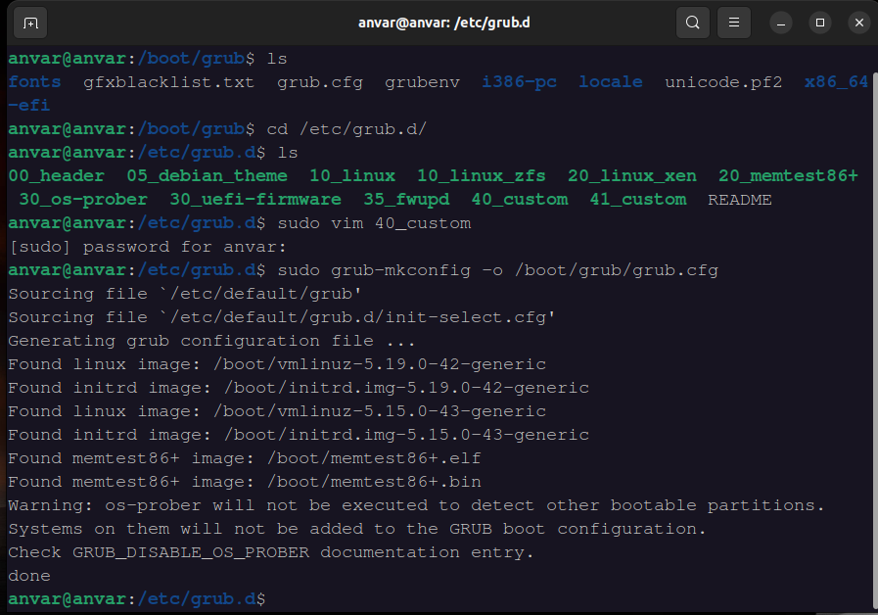

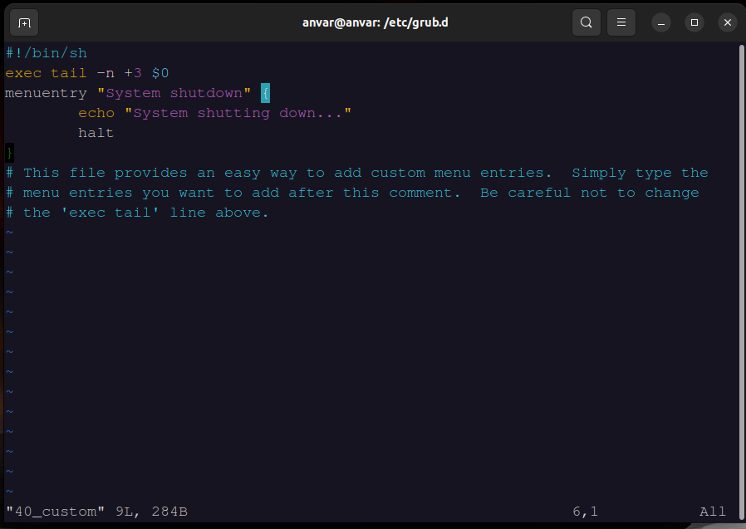



-Used “grub-mkconfig” command for configuring “grub.cfg”

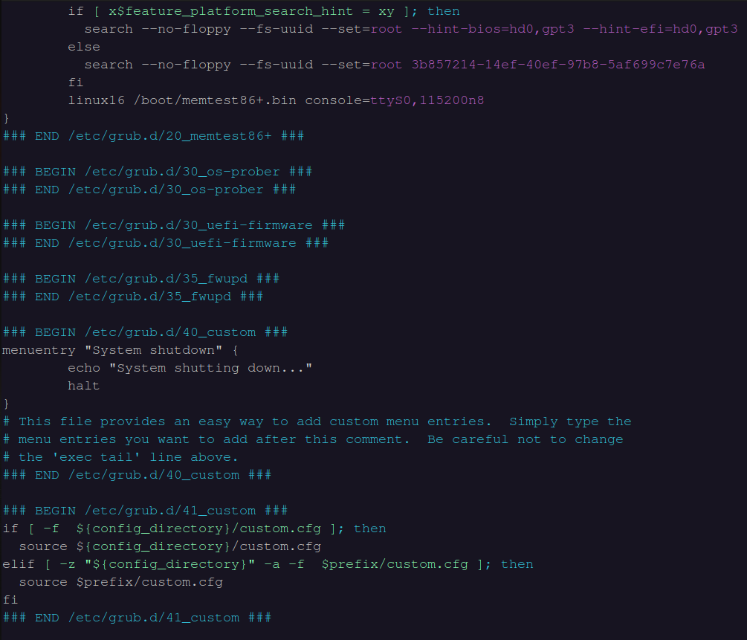

-This is script inside “grub.cfg” after configuration.

-“manurentry” in script is for manual entry

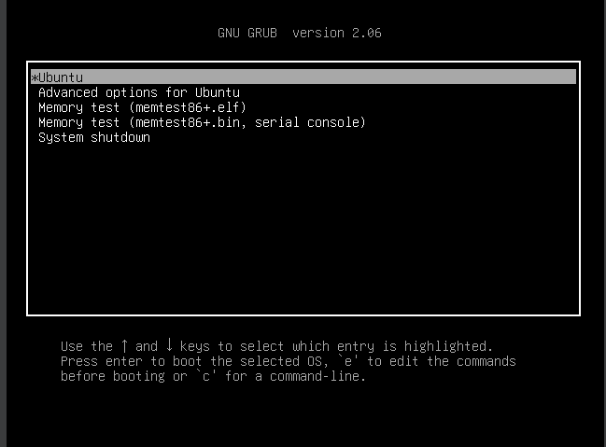

-Result.Shutdown added to GRUB boot menu.

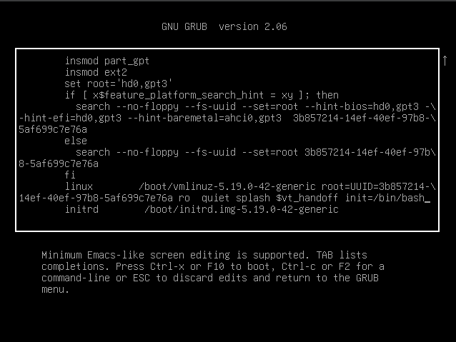

-Press “e” in GRUB

-Write “init=/bin/bash” end of kernel line starts with linux

-Press F10 for boot server into single-user mode and write commands for reset root password.

-To remount a filesystem as read-write (rw) in Linux, you can use the mount command with the remount option.

-“/”is for read, write in root directory

-passwd root is for reset password

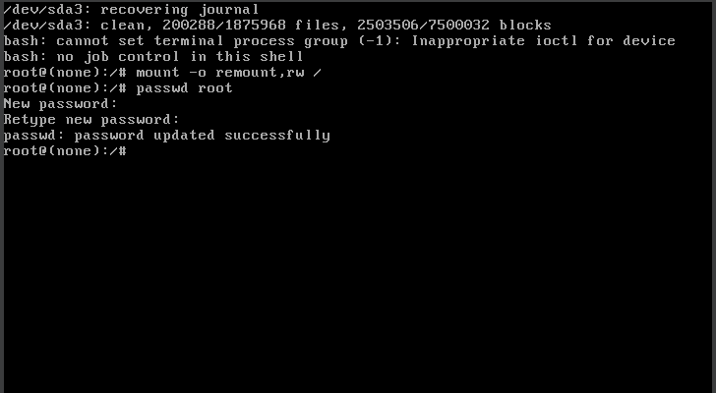

-reboot with “reboot -f”

3. Write a Bash script to perform regular backups of specified directories.

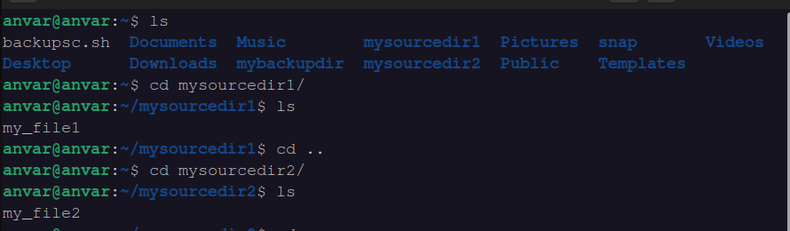

-mysourcedir1 and mysourcedir2 are source directories/

-mybackupdir is backup directory.

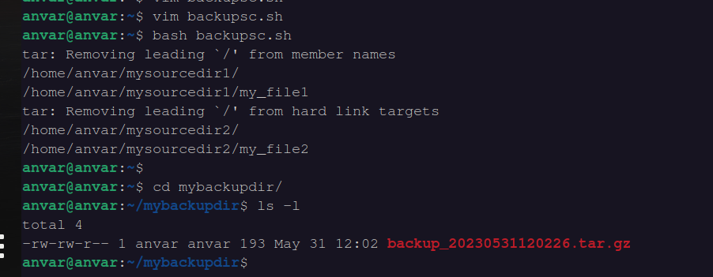

-this is backup “tar ” file in backup directory

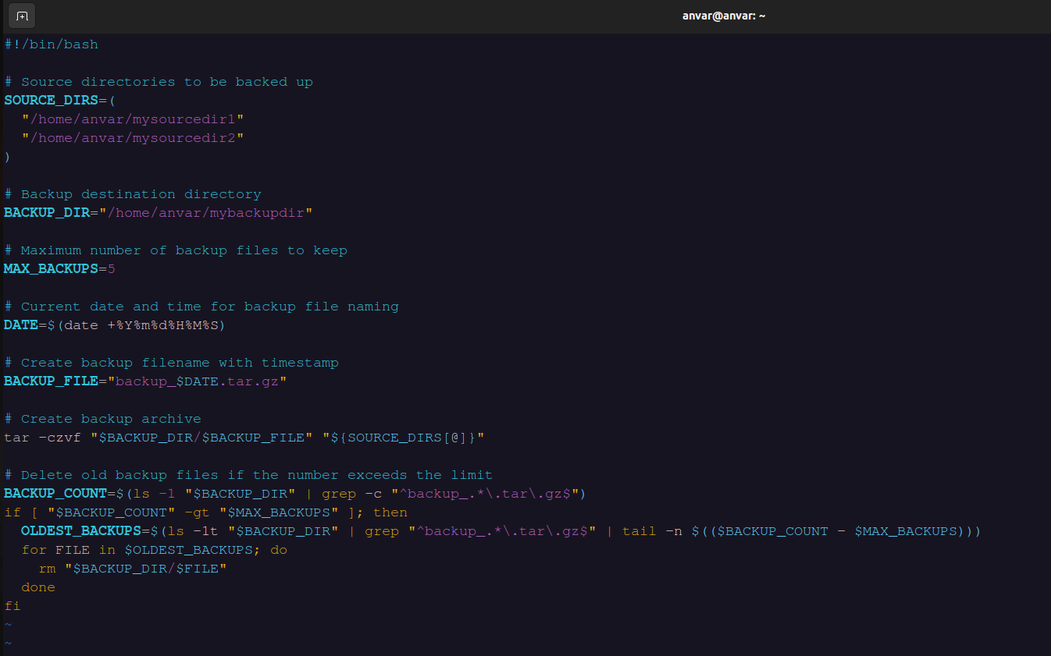

-only 5 backup files are allowed

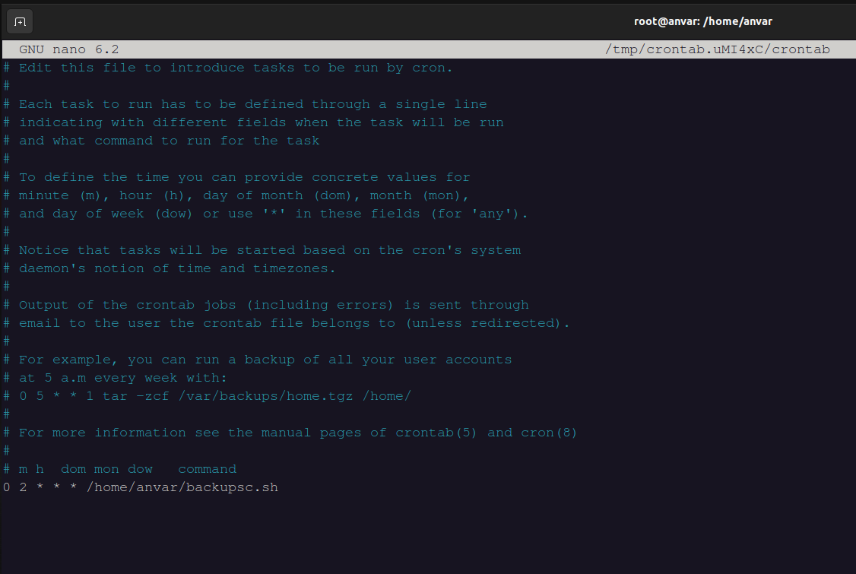

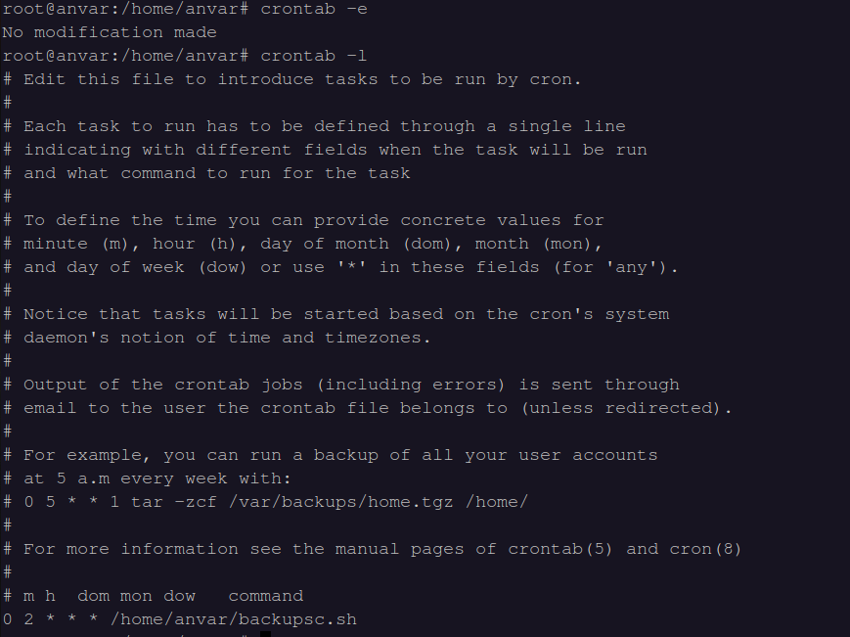

-cron tab configured to run this command everyday at 2PM

4.Process Management and System Monitoring

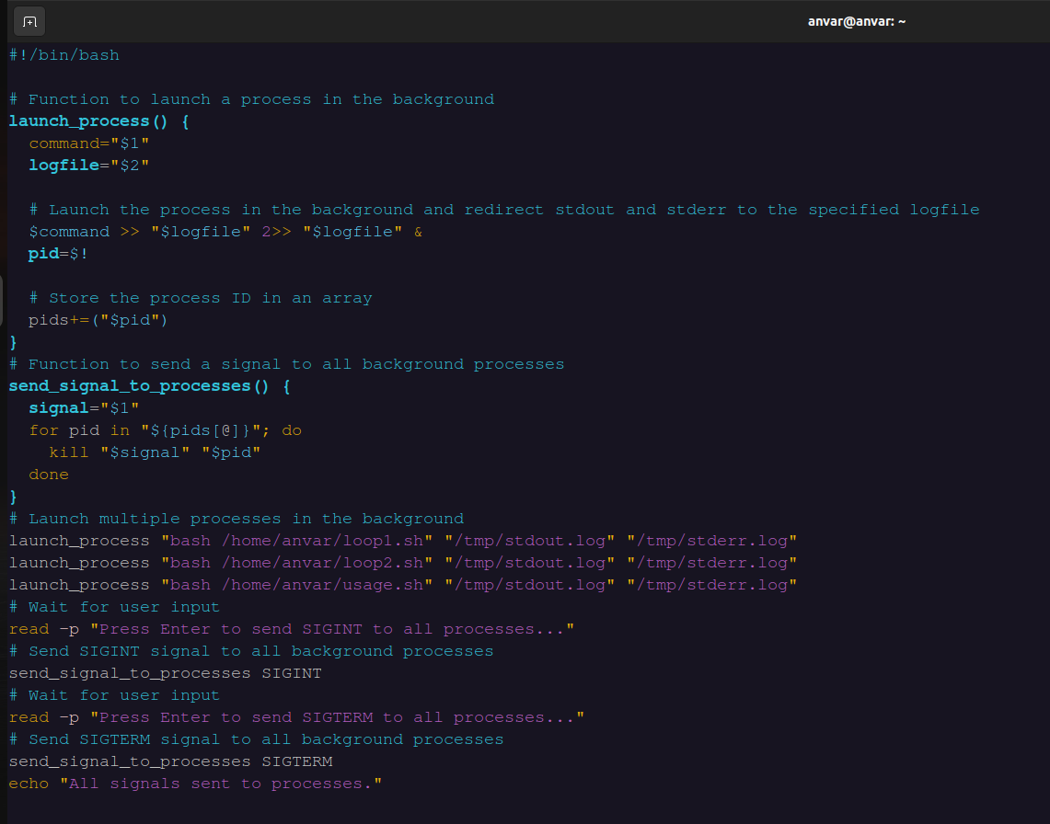

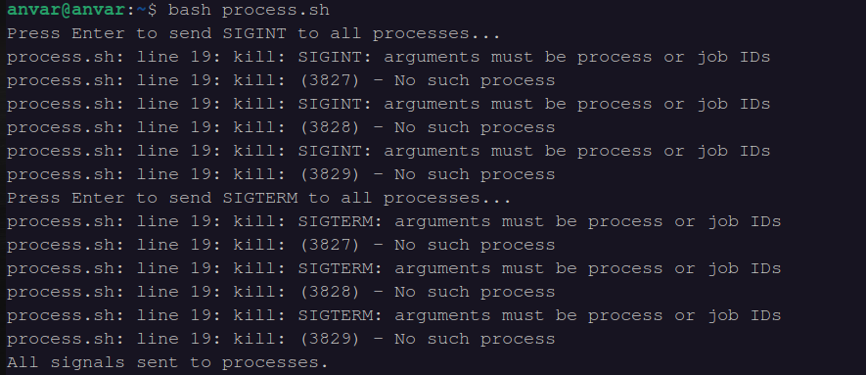

-Script starts 3 different processes at backround

-Script creates “stdout.log” file when we run script

-it creates “stderr.log” file if error occur.

- SIGINT is the signal sent when we press Ctrl+C

-SIGTERM is used to terminate process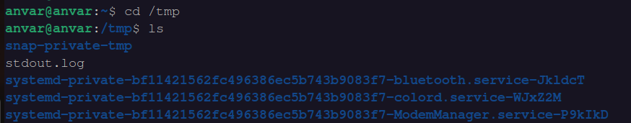

-stdout.log file for in tmp directory.

